**CREATE A PROJECT ON ECLIPSE**

**Following are the steps to create a project on eclipse.**

* Click on file, then on New and then select other... option.

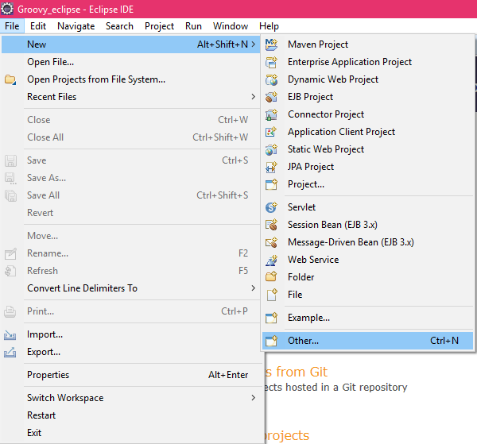

* Now search for the groovy and select groovy project.

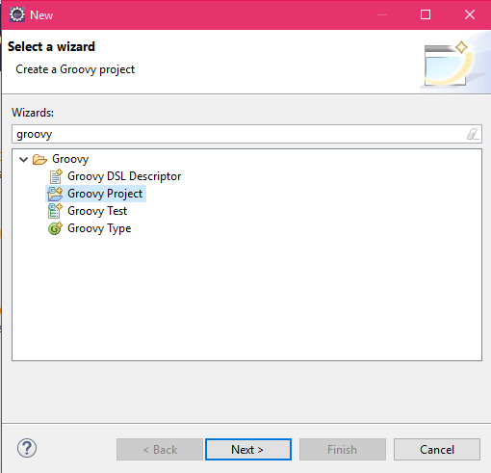

* Give a project name and click on next button.

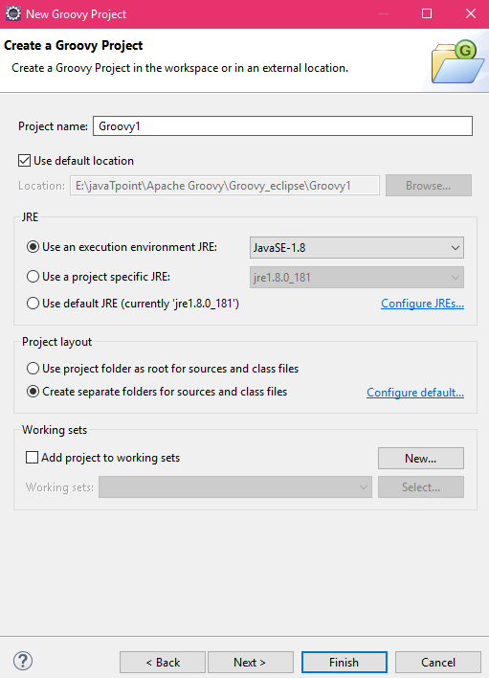

* click on finish button.

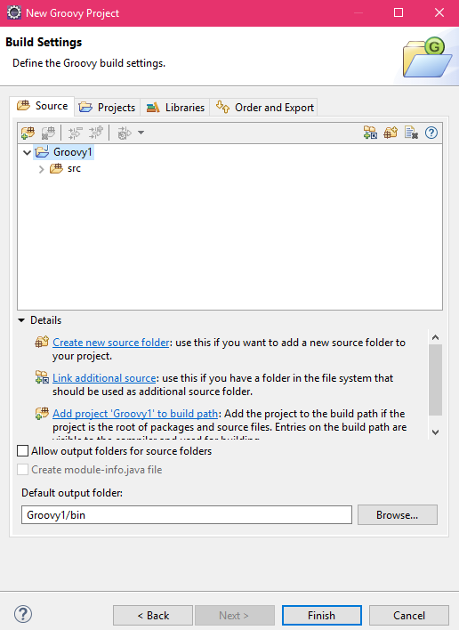

How to add a class in the groovy project

* In your project, right click on src folder, click on New and then click on other.

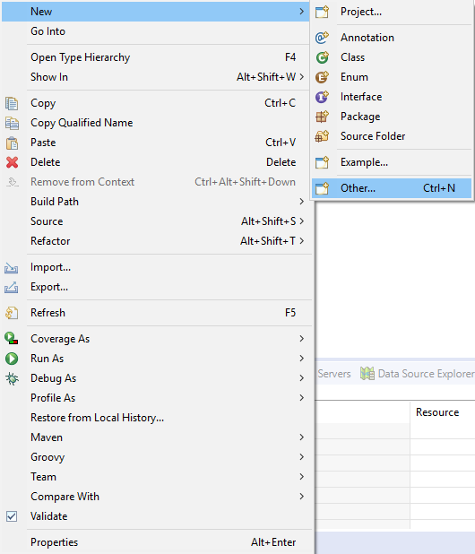

* Click on the groovy type and then on the next button.

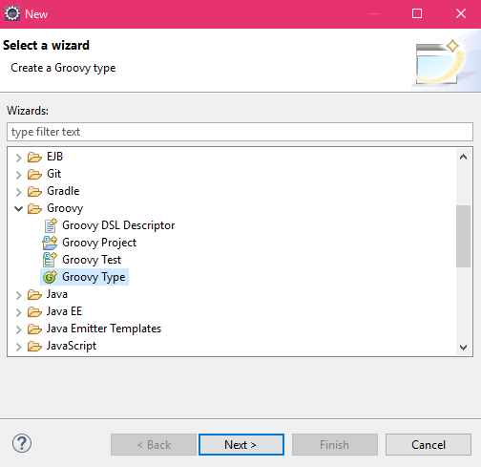

* Now select the kind, here we are selecting Class. Now give the Package name and class Name. and click on next button.

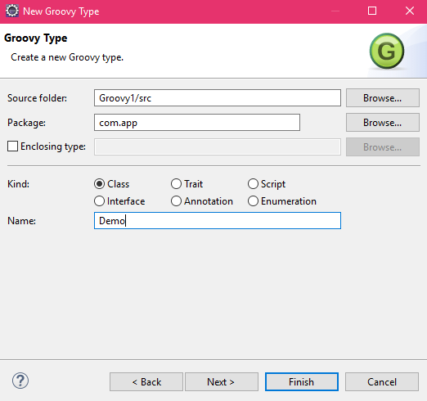

* Here we have some more options. Now I am selecting static void main(args). And click on the finish button.

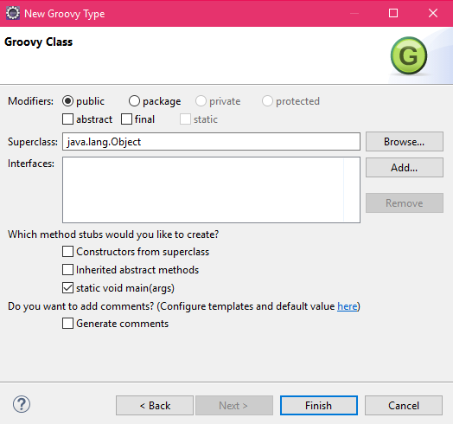

* The below screen shows that the class has been created.

